Standard Operating Procedure (SOP) #10

Conducting Community Vegetation Monitoring

Version 2.0 (October 4, 2022)

Change History

|  |  |  |  |  |  |
| --- | --- | --- | --- | --- | --- |
| New Version # | Revision Date | Author | Changes Made | Reason for Change | Previous Version # |
| 2.0 | 10/4/2022 | Kathryn Akamine, Jacob Gross, Alison Ainsworth | Updated methodology | Clarified and updated methods based on the completion of the second cycle of sampling. | 1.0 |
|  |  |  |  |  |  |
|  |  |  |  |  |  |
|  |  |  |  |  |  |
|  |  |  |  |  |  |
|  |  |  |  |  |  |

Only changes in this specific SOP will be logged here. Version numbers increase incrementally by hundredths (e.g., version 1.01, version 1.02) for minor changes. Major revisions should be designated with the next whole number (e.g., version 2.0, 3.0, 4.0). Record the previous version number, date of revision, author of the revision, changes made, and reason for the change along with the new version number.

Purpose

This SOP describes how to collect Pacific Island Network (PACN) Focal Terrestrial Plant Communities (FTPC) monitoring data to quantify plant composition and structure. Data on different plant life forms are collected in different sized plots to maximize the efficiency of field sampling. A master equipment list for the entire FTPC monitoring protocol can be found in SOP #1 Before the Field Season. The master equipment list should be updated as needed if this SOP is revised. Procedures for navigating using a GPS (Global Positioning System) unit are provided in SOP #6 Using Garmin® GPS Units. Prior to navigating to a plot, sanitation procedures outlined in SOP #4 Sanitation Protocol must be followed. Once at a plot, procedures to establish a plot is explained in SOP #9 Establishing and Marking Vegetation Monitoring Plots. Procedures for taking photographs and points in Field Maps are provided in SOP #8 Using ArcGIS® Field Maps App. Data forms for recording field observations are in Appendix E: Forms for Recording Field Data.

Table of Contents

Standard Operating Procedure (SOP) #10 1

Conducting Community Vegetation Monitoring 1

Change History 1

Purpose 1

Sampling Plot Design and Vegetation Parameters 4

Wet forest, subalpine shrubland, limestone forest, and mangrove forest communities 4

Coastal Communities 5

Recording Data 5

Documenting Plot Location & Plot Comments (Form 1) 6

Documenting Species Presence (Form 3) 8

Photographing the Plot (Form 2) 11

Quantifying Coarse Woody Debris (Form 10) 13

Conducting Vegetation Cover Surveys (Form 4) 14

Conducting Woody Vegetation and Tree Fern Density Counts (Forms 5, 6, 7, 9, 11, 12, 15) 18

Wet Forest, Limestone Forest, and Mangrove Forest Communities 24

Large Trees (Form 9) 24

Canopy Height (Form 8) 28

Large Tree Ferns (Form 7) 29

Small Trees (Form 6) 30

Small Tree Ferns (Form 5) 31

Tree Seedlings (Form 5) 31

Shrubs (Form 5) 32

Vines (Form 5) 32

Subalpine Shrubland Community 33

Small and Large Trees (Form 11) 33

Tree Seedlings, Shrubs, Small tree ferns, and Vines (Form 12) 33

Coastal Community 34

Large Trees (Form 9) 34

Small Trees, Tree Seedlings, Shrubs, and Vines (Form 15) 34

Canopy height 35

Definitions 35

Literature Cited 36

Sampling Plot Design and Vegetation Parameters

Wet forest, subalpine shrubland, limestone forest, and mangrove forest communities

All plots established in wet forest, limestone forest, mangrove forest, and subalpine shrubland communities have 20 x 50 m dimensions (Figure SOP 10.1). Species presence and large tree density are recorded within the entire plot. Understory vegetation cover and surface substrate type are read along three transects: two of which make up the long sides of the plot, and one centerline that runs parallel to the long sides. Within each 20 x 50 m plot there is a nested 10 x 25 m subplot (Q4) and 2 x 50 m subplot (along TR 3). Large tree fern densities are read within the entire 20 x 50 m plot in all sampling frames *except in KALA and HAVO wet forest communities where they are only measured in the 10 x 25 m subplot*, quadrant 4 (Q4), due to high densities. Small trees are measured within the 10 x 25 m subplot (Q4) in all sampling frames *except in HALE and HAVO subalpine shrubland communities* where they are counted throughout the entire 20 x 50 m plot, due to low densities. Tree seedling, small tree fern, shrub, and vine density are recorded within the 2 x 50 m subplot (along TR 3). Coarse Woody Debris (CWD, ≥7.6 cm) are counted along the center 50 m transect (TR 2) and two outer 20 m transects (TR 4 and TR 6) using the planar intercept technique. Large dead tree ferns (≥7.6 cm) with no distinguishable terminal end (i.e., where the fiddleheads originate) are recorded with CWD.

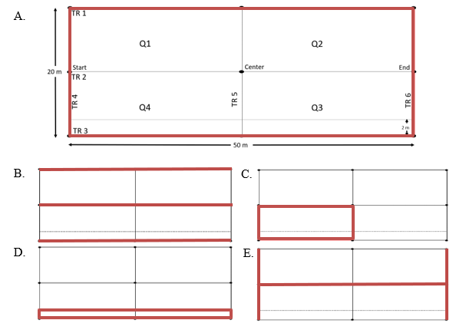

**Figure SOP 10.1.** Wet forest, subalpine shrubland, limestone forest, and mangrove forest sampling plot layout used to quantify vegetation composition and structure. The different plot/subplot sampling areas are identified by red. A) The entire 50 x 20 m plot [species presence, large trees, large tree ferns]. B) The three long (50 m) transects (TR 1-3) [plant species cover]. C) The 10 x 25 m subplot (Q4) [small trees]. D) The 2 x 50 m subplot that runs along TR 3 [tree seedlings, shrubs, vines, small tree ferns]. E) The two outer short (20 m) transects (TR 4 and TR 6) and long (50 m) center transect (TR 2) that create an “I” shaped sampling area [coarse woody debris].

Coastal Communities

All plots established in the coastal community measure 10 x 20 m (Figure SOP 10.2). Species presence and large tree density are recorded within the entire plot. Understory vegetation cover and surface substrate are read along three transects: two of which make up the long sides of the plot (TR 1 and TR 3), and one centerline (TR 2) that runs parallel to the long sides. Within each 10 x 20 m plot, lie two nested 2 x 20 m subplots (along TR 1 and TR 3). Small tree, tree seedling, shrub, and vine densities are read within both 2 x 20 m subplots. Large CWD (≥7.6 cm) are counted along the 20 m centerline (TR 2) and two 10 m transects (TR 4 and TR 6) using the planar intercept technique.



**Figure SOP 10.2.** Coastal communities sampling plot layout used to quantify vegetation composition and structure. A) The entire 20 x 10 plot [species presence and large trees]. B) The three long (20 m) transects (TR 1-3) [plant species cover]. C) The two 2 x 20 m subplots that run along TR 1 and TR 3 [small trees, tree seedlings, vines, and shrubs]. D) The two outer short (10 m) transects (TR 4 and TR 6) and long (20 m) center transect (TR 2) that create an “I” shaped sampling area [coarse woody debris].

Recording Data

All data forms have the same header that should be filled out. The header includes: 1) Park Code, 2) Plant Community, 3) Location (Sampling Frame), 4) Plot #, 5) Date, and 6) Observers. All these items should be filled out on each data form, on both the front and back. Keep handwriting legible. The “Observers” field should list the data recorder initials first so if there are any follow up questions upon data entry/analysis, the data recorder can be referred to. Form 1, Plot Location, should have initials of every crew member that worked in the plot. Some data forms require multiple pages if space on the first page is exhausted (e.g., Form 9, Large tree density). If more than one page of the same form is used, the bottom of the page should be filled out to state page number and total pages (e.g., Page 1 of 4, Page 2 of 4, etc.). Prior to field work, field crew lead should have all necessary data forms and extra pages printed. Additionally, all previously sampled fixed plots datasheets will be accessible to crew in the field on tablet for reference. Types of data forms needed vary depending on community, see Table SOP 10.1 for list of data forms. Table SOP 10.2 shows a breakdown of what parks are monitored during each cycle and the associated communities.

**Table SOP 10.1.** Vegetation communities monitored in the PACN network and corresponding data forms used. Original data forms 13, 14, and 16 were combined into other forms.

| Community | Form 1 | Form 2 | Form 3 | Form 4 | Form 5 | Form 6 | Form 7 | Form 8 | Form 9 | Form 10 | Form 11 | Form 12 | Form 15 |
| --- | --- | --- | --- | --- | --- | --- | --- | --- | --- | --- | --- | --- | --- |
| **Wet Forest** | x | x | x | x | x | x | x | x | x | x | - | - | - |
| **Mangrove Wetland** | x | x | x | x | x | x | - | x | x | x | - | - | - |
| **Limestone Forest** | x | x | x | x | x | x | - | x | x | x | - | - | - |
| **Subalpine Shrubland** | x | x | x | x | - | - | x | - | - | x | x | x | - |
| **Coastal Strand** | x | x | x | x* | - | - | - | - | x | x | - | - | x |

*Data forms are the same except for adjustments to account for differences in plot size. Be sure to use the correct data form.

**Table SOP 10.2.** Park, Park code, Plant communities, and Sampling Frame organized by Cycle Year.

| Cycle Year | Park (Park Code) | Community | Sampling Frame |
| --- | --- | --- | --- |
| **1** | Hawaiʻi Volcanoes National Park (HAVO) | Wet Forest | ʻŌlaʻa  Nāhuku /East Rift |
|  |  |  |
| **2** | Hawaiʻi Volcanoes National Park (HAVO) | Subalpine Shrubland  Wet Forest | Mauna Loa  Kahuku |
|  |  |
|  | Kaloko-Honokōhau National Historical Park (KAHO) | Coastal Strand | Kaloko-Honokōhau |
| **3** | Haleakalā National Park (HALE) | Wet Forest | Kīpahulu District |
|  |  | Subalpine Shrubland | Haleakalā |
| **4** | Kalaupapa National Historical Park (KALA) | Wet Forest | Puʻu Aliʻi |
|  |  | Coastal Strand | Kalawao |
|  |  |  | Hoʻolehua |
| **5** | National Park of American Samoa (NPSA) | Wet Forest | Tutuila |
|  |  |  | Ta‘ū |
| **6** | War in the Pacific National Historical Park (WAPA)  American Memorial Park (AMME) | Limestone Forest  Mangrove Wetland | Guam  Muchot |
|  |

Documenting Plot Location & Plot Comments (Form 1)

Latitude and longitude of start, center, and end of center transect (TR 2) **are collected with a GPS device at all plot locations**. Physically writing the coordinates on the datasheet is required (used as a backup) for rotational plots, new fixed plots, or fixed plots with coordinate errors. Fixed plots with accurate coordinates (i.e., GPS point matches the post location) do not require hand-written latitude and longitude on the datasheet, instead just write “good” across the coordinates section. When recording longitudinal coordinates for Hawaiian Islands that there should be a negative sign (-) to indicate coordinates are in the western hemisphere.

To understand the extent of time and effort it takes for crews to access and complete a plot the following information is recorded: Starting Location, Location Parked (if driving), Total Drive Time, Total Hike Time, Time Arrived at Plot, Plot Set up Time, and Time Monitoring (Start and End time).

If a crew is visiting a new plot (e.g., rotational), or using a new route to a fixed plot, helpful instructions for future access should be included, such as: 1) any roads/trails used to reach the plot, 2) the point at which the field crew left road/trail access to reach the plot, and 3) the route used to reach the plot (i.e. did crew take direct route or follow a fenceline or topographic feature?). A section of the location form is available to record problems encountered, changes, and comments. Any non-standard methods of data collection need to be documented here. Fixed plots should have permanent posts; crew should note if any posts are missing/replaced or additional posts are installed. The program lead will read this section for each plot during data certification. **Providing detailed notes on the location form “comments” section is the best way to ensure protocol and data issues are permanently documented and corrected.**

The field leader or a designated crew member with good attention to detail creates a hand drawn map of the plot. A map should be drawn for all plots; however fixed plots require extra detail and information, complete with permanent post locations and notes if post was offset and distances and directions from witness trees to the permanent posts (See SOP #9 Establishing and Marking Vegetation Monitoring Plots). It is essential that clear text be included for locating plots and future plot setup so that the plot can be reread even if posts are missing (Figure SOP 10.3). It is also helpful for any other distinct features (proximity to road, trail, or fence line, topography, disturbances, etc.). Other important items to note on the map include rare or endangered species so that crews can easily note presence or absence of the species in the future. Hand drawn maps need to be updated for each fixed plot. Good notes are important as future field crews will rely on the details of this page.

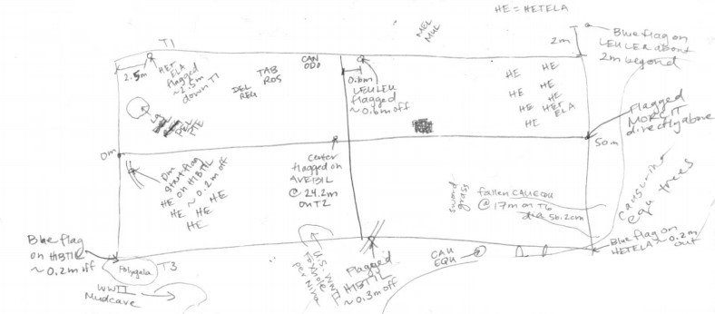

**Figure SOP 10.3.** Plot Location map to assist with plot set up and logistics.

The last part that needs to be filled out on Form 1 is the “Field Verified Checklist”. The purpose of this checklist is to promote quality control of field data while in the field and crew can address any remaining questions or issues. The field lead should review all data forms and initial next to each item that is checked. These items include: Any missing data, all data legible, Species list and photos complete.

Documenting Species Presence (Form 3)

Species presence data are recorded in each sample plot within all communities. Once plot installation is complete, the field crew should briefly survey the plot as they make their way back to the “home base”. The field crew will record all species rooted within the plot boundaries (forest communities and subalpine shrubland: 20 x 50 m; coastal: 10 x 20 m). The field crew constructs a checklist of all species present and records whether the plants show any sign of reproduction (e.g., fruits and/or flowers, sporangia on ferns, etc.) using the Species Presence data form. It is recommended that the designated field lead oversees recording species. All species within a plot should be identified and recorded, this includes unknown species. Dead species are recorded as “dead” in the comments section only if there are no live individuals rooted in the plot. The six-letter code for a species can be used on the Presence form if the species is common and the code is well known to all crew members. If the species is uncommon, or the species needs further identification then the full scientific name should be written out on the form. Additionally, when recording a species code, the park specific species list should be reviewed as there may be duplicate 6-letter codes that are distinguishable by a suffix (e.g., *Asplenium horneri* = ASPHOR2 and *Asplenium horridum* = ASPHOR3). **Field crew leads should be aware when duplicate codes occur and make all crew members aware of it.** In these situations, it is best to write out the full species name or enough additional letters to differentiate which species is being recorded.

Species presence is the first and last thing that the crew will discuss as a group. During plot set up, field crews should be conscious of their surroundings and attempt to minimize disturbance to vegetation, especially along transect lines where understory cover is recorded. Once plot set up is complete, the crew can review what species were seen within the plot’s boundaries and begin to record these species. Because some disturbance is inevitable, it is recommended to complete all monitoring in plot before doing a final walk through. A thorough survey can be accomplished by walking through the plot within a reasonable amount of time (i.e., 15 minutes or less for a four-person field team). Prior to leaving the plot, the crew should go over the species list together. Data forms should be looked over to verify that data is complete, and any additional species found within the plot during this sampling event are added to the Species Presence data form. If the crew recorded a species on the cover transect that was only found rooted out of the plot, the species should be recorded on the presence sheet and noted as “out”. Other plants of interest (e.g., rare or incipient species) can also be noted on the presence sheet as “out” if found near the plot. At fixed plots, the crew should refer to presence datasheets from prior cycles to compare documented species. Any large discrepancies in species presence or abundance should be highlighted in the plot comments (form 1).

Unknown Species

When unknown species are present within the plot and the **crew does NOT have an educated guess** for the species, an unknown alias code (Table SOP 10.3) can be used as the place holder. For example, the recorder would write “Unk_Fern1” on the Presence form and use “Unk_Fern1” on the other forms as well. If another unknown fern is encountered, then “Unk_Fern2” would be used.

**Table SOP 10.3.** List of unknown codes available in database, each code has 5 unique entries available (e.g., Unk_Fern2, Unk_Fern3, etc.) and can be used if multiple unknown species of the same lifeform exist in a plot.

| Unknown Alias Codes |
| --- |
| Unk_Fern1 |
| Unk_Grass1 |
| Unk_Herb1 |
| Unk_Palm1 |
| Unk_Rush1 |
| Unk_Sedge1 |
| Unk_Seed1* |
| Unk_Shrub1 |
| Unk_Tree1 |
| Unk_Vine1 |

*Unk_Seed1 is used for unknown seedlings

Alternatively, when unknown species are present within the plot and the crew **has an educated guess of the species,** that educated guess can be used as a placeholder until the species can be identified. A **question mark “?” is used to indicate any species needing follow-up identification**. For example, if an unknown species is encountered and the crew thinks it is the fern *Dryopteris glabra* but are unsure, then the full species name is written on Presence Form 3 with a question mark (e.g., *Dryopteris glabra*?). On other datasheets (e.g., Understory Cover), the six-letter code can be used along with the question mark (ex. DRYGLA?). Unknown species (referred to simply as “unknowns”) include all “unknown alias codes” and all species with question marks on the presence form.

“Unknowns” require specific documentation to help identify and track species, not only during the monitoring season, but also as a reference for future field crews. ESRI’s Field Maps App will be used for all sampling photos (e.g., plot photos, plant photos, etc.). All unknowns require a “Field Maps” point. See SOP #8 Using ArcGIS® Field Maps App for guidance on using ESRI’s “Field Maps” App. This point should be named to match the Unknown Name (either “Scientific name?” or unknown alias code). The point will automatically record a GPS point and allow an unlimited number of photos to be linked with the point. Multiple photos should be used to capture important plant features (e.g., buds, flowers, fruits, leaf arrangement, venation, stipules, hairs, etc.). Along with detailed photos and related notes should be recorded (e.g., description of characteristics not obvious in the photos, such as measurements, aromatic properties, texture, etc.). Plant samples (i.e., voucher specimens) are collected, whenever possible, to assist with identification. All voucher specimens should be taken from outside of the plot. When collecting physical vouchers, samples should be kept in a Ziploc bag along with a piece of Rite-in-the-Rain paper noting the community, sampling frame, plot #, and the Unknown Name (either “Scientific name?” or unknown alias code). The Unknown Name in “Field Maps” and the voucher bag should match exactly with the Unknown Name written on the Presence Form.

The use of a “?” is sufficient on datasheets; however, the taxonomic level of confidence should be recorded in “Field Maps” (“Taxon confidence” drop down menu) when plant photos are taken. The level of confidence (Table SOP 10.4) gives a gauge in confidence in identification and to what taxonomic level. Any species with a “?” on the Presence form should be entered in “Field Maps” and should have a confidence rating from 2-4. This rating is not necessary to note on the datasheet as the rating may change as follow-up identification is conducted and tracked in Arc GIS Online (AGOL).

All unknown species should be identified by at least two different crew members and the AGOL table should be updated with findings. **When unknown species are identified/confirmed all datasheets should be updated to reflect correct/final scientific name.** This scientific name may or may not include additional taxonomic nomenclature (cf.) and all final identification should not have a “?”.

**Table SOP 10.4.** Level of confidence in species taxonomy. Every plant photo taken in “Field Maps” should have a species assigned and a level of confidence in its identification.

| Level of Confidence | Taxonomic Nomenclature | Description |
| --- | --- | --- |
| 1 | Unknown | Unknown with no idea/placeholder |
| 2 | Looks similar to… | Unsure, but looks similar to… |
| 3 | cf. genus | Family confirmed, but "not sure" about the genus |
| 4 | cf. species | Genus confirmed, but "not sure" about the species |
| 5 | confirmed species | Species is confirmed, just documenting |

In taxonomic nomenclature **cf.** means to “compare to” or “confer” and is commonly placed in front of the taxonomic level that is uncertain (example: “*Acacia* cf*. confusa*” if genus is certain but species is not certain). Crew leaders are encouraged to use their expert knowledge and select the most likely species. For example, *Labordia* cf*. hedyosmifolia* is preferred to *Labordia* sp*.*, especially if environmental variables (e.g., elevation) can help support the decision. *Coprosma* cf. *ochracea* is preferred to *Coprosma* sp. because we can then rule out other obviously different species of the same genus, like *Coprosma ernodeoides*. Just be sure to record your reasoning. If “cf.” is used on the presence sheet, then accompanying notes describing the uncertainty and photos are expected. DO NOT use cf. as shorthand for “confirmed”.

**After the unknown species is identified**, all data forms that may have the unknown record should be updated, all records (GPS points) in the GIS (AGOL) “Unknown Plants” table are also updated, and the sample is sent to the park’s herbarium or discarded properly (refer to SOP #4 Sanitation Protocol). If the field crew identifies a species that is new to the park, or to a specific unit within the park, additional steps should be taken to add the voucher to the appropriate herbarium (refer to SOP #12 Collecting and Vouchering) and to add it to NPSpecies and our park species list (this will be done by the Project Lead and data management team).

Refrain from species removal in and around plots

When conducting vegetation monitoring it may be tempting to remove/uproot species that are known to be incipient or invasive in nature, especially if these species are in areas that will most likely not be visited by anyone soon. The purpose of I&M’s vegetation protocols is to monitor the temporal and spatial changes in vegetation. It is imperative that crews do not take actions that may disproportionately influence future vegetation sampling. Pulling a weed in a fixed plot without removing the surrounding population will result in an underestimate of invasive plant abundance and could negatively impact monitoring results and resource management guidance. Instead of removing invasive species, the crew should note the area of the occurrence and communicate with resource management staff so a proper sweep of the area can be conducted.

As mentioned previously, crews may remove portions of a plant or even uproot an individual to assist with species identification. This is following guidelines (refer to SOP #12 Collecting and Vouchering) that ensure that any species removal will not have a dramatic change on the plant population in the area.

I&M should work with NPS resource management. Prior to the field season there may be a list of target species that crews should look out for, take GPS points, and other field notes. This may be a rare and endangered species (any species on Threatened and Endangered provided by NRM) or target invasive species that need active management (e.g., *Sphaeropteris cooperi* in HAVO).

Photographing the Plot (Form 2)

Photographs are taken at every plot. Nine photo points are patterned after the photo points in the NPS Fire Monitoring Handbook (2003), with an additional four photos taken at the plot center. These photographs include: four from the midpoints of TR1, TR3, TR4, and TR6 towards the plot centroid (CenterT1-CenterT2, CenterT3-CenterT2, StartT2-CenterT2, EndT2-CenterT2), four from the plot corners facing the long edge of each plot (StartT1-CenterT1, StartT3- CenterT3, EndT1-CenterT1, EndT3-CenterT3?), one of the canopy taken from the plot centroid (CenterT2-Canopy), and four additional photos taken from the plot center towards the corners (Quadrant 1, Quadrant 2, Quadrant 3, Quadrant 4). These plot photos provide qualitative information that can aide in communicating patterns of vegetation change to a wide audience. All these photos should be taken with the camera at a height of 1.4 m and “landscape” orientation of camera. For photos taken where any movable foliage is directly obstructing the view of the photographer, the photographer may move it to get a more accurate photo if it does not cause any permanent damage to the plant.

Additionally, at least two photos are taken for the “start” and the “end” permanent marker posts of transect 2 (Figure SOP 10.4) to assist with post relocation. These post photos should include at least two photos to get an idea of where it exists in the landscape (including witness tree if possible). At least one photo of staff working within the plot is highly encouraged and valuable for presentations and reports. The time each photo was taken is entered on the photo datasheet (form 2) and when the photo datasheet is complete a photo is also taken of the photo datasheet itself. Additional photos of the plot are encouraged and can be taken using the “Other” category along with comments. These photos can include trees requiring non-standard measurement techniques (tree complex, visual estimate of DBH, obstructing epiphytes, etc.), plot disturbance (pig damage, plot set-up damage, fallen trees, etc.), a beautiful view, etc. Pictures are an easy and efficient way to convey information and they are always helpful for presentations and SOPs.



**Figure SOP 10.4.** Schematic of the plot showing the eight photo points for fixed plots and the four quadrant photos. Each arrow represents one photo and is labeled according to the location of the photographer and the location of the subject (or photo target). For example, an arrow shows one photo taken at the “Start” of TR2 looking toward the “Center” of TR2. For rotational plots, only three photos need to be taken: Start to Center, Center, and Canopy. Schematic does not show photos that do not have a set directional/positional requirement (i.e., post photo, canopy photo, staff photo, and Photographic Record data form).

Rotational plots require only nine photographs. Photographs of rotational plots are taken from the start and end of the centerline toward the centroid, one of the canopy at plot centroid, four quadrant photos from plot centroid, one staff photo, and the completed Photographic Record.

Quantifying Coarse Woody Debris (Form 10)

Coarse woody debris (CWD), or downed wood and downed tree ferns with no distinguishable terminal end, are recorded along the centerline (TR 2) and the two short transects forming the plot border (TR 4 and TR 6) for each plot (Fig SOP 10.1 and 10.2) using a planar intercept technique. Large CWD (≥7.6 cm diam.) that are within 2 m of the ground and that intersect the transect using the planar intercept technique will be recorded. The diameter of the CWD is taken at the point where the tape crosses the wood. Additionally, recorded CWD will be assigned one of five decay classes (Table SOP 10.5). Wood must be downed and dead to be counted. Stems and branches attached to standing shrubs or trees are not included. If the transect intersects a curved piece more than once, each intersection is recorded. Uprooted stumps are recorded, but undisturbed (i.e., standing dead) stumps are not. For rotten logs that have fallen apart, the cylinder containing rotten material is visually reconstructed to estimate its diameter. Dead trees leaning <45 degrees from the ground are recorded as CWD, while dead trees leaning 45-90 degrees (i.e., standing dead) from the ground are recorded on the Large trees datasheet (Form 9).

**Table SOP 10.5.** Decay classes for logs with diameters ≥7.6 cm (USDA Forest Service 2005).

| Decay Class | Structural Integrity | Wood Texture | Color of Wood | Branches and Twigs | Invading Roots |
| --- | --- | --- | --- | --- | --- |
| 1 | sound, freshly fallen, intact logs | intact, hard, decay absent | original color | twigs present; bark tight | none |
| 2 | sound | mostly intact; sapwood partly soft (starting to decay) but cannot be pulled apart by hand, heartwood is mostly sound | original color | fine twigs gone; bark peeling | none |
| 3 | heartwood sound; piece supports its own weight | hard, large pieces, partly decaying; sapwood can be pulled apart by hand or sapwood absent | reddish-brown or original color | branch stubs will not pull out | sapwood |
| 4 | heartwood rotten; piece does not support its own weight, but maintains its shape | small, blocky pieces; a metal pin can be pushed into heartwood | reddish or light brown | branch stubs will pull out | heartwood |
| 5 | piece no longer maintains its shape, spreads out on ground | many small pieces, soft portions; powdery when dry | red-brown to dark brown | branch stubs and pitch pockets have rotted down | heartwood |

Tree fern are counted as CWD when the caudex cannot be traced to the live fronds on the terminal end (i.e., no obvious terminal end of caudex) or when the tree fern caudex is no longer rooted in the ground (i.e., a log). Dead tree ferns counted in CWD must be laying on the ground. If the tree fern is dead and standing it is not recorded as CWD. Standing-dead tree ferns are instead recorded on the large tree fern datasheet (Form 7) or small tree fern datasheet (Form 5). Caudex diameter and decay class are recorded for each tree fern log (with no distinguishable terminal end) intersecting the transect plane. Three decay classes are used for tree fern logs with numbering generally consistent with CWD wood (1) freshly fallen, (3) sound, intact, and supports its own weight, and (5) old dead, decomposing and soft.

Conducting Vegetation Cover Surveys (Form 4)

Understory plant cover data are recorded in each plot along the three long transects (TR 1, TR 2, and TR 3) using the pole intercept method, which is a variation on the point-intercept method (Mueller-Dombois and Ellenberg 1974, Elzinga et al. 2001). In the wet forest, subalpine shrubland, limestone forest, and mangrove forest communities, transects are 50 m long and point data are recorded every 0.5 m along each transect starting at 0.5 m and ending at 49.9 m (to avoid the post or flags), totaling 100 points per transect and 300 points per plot (Figure SOP 10.1). In the coastal community, transects are 20 m long and point data are recorded every 0.2 m along each transect starting at 0.2 m and ending at 19.9 m (to avoid the post or flags), totaling 100 points per transect and 300 points per plot (Figure SOP 10.2). When standing at the start of TR2, the left long edge of the plot is TR1 which includes points 1 – 100, TR 2 (the centerline) includes points 101 – 200, and TR 3 (the right long edge of the plot) includes points 201 – 300. Form 4 has the transect number and meter segment identified to make recording easier for the crew. Be sure to use the correct Form 4, as there are two variations to account for the two different plot sizes.

At each point along the transect, a 2 m long pole (a collapsible tent pole with 1 m and 2 m marked for reference) is held plumb to the ground on a side of the transect such that cover sampling occurs within the plot. On a slope, a plumb pole will not be perpendicular to the surface; instead, the pole should stand completely vertical regardless of the angle of the ground. Surface substrate is identified as the surface available for seedling establishment as opposed to underlying soil types. See Table SOP 10.6 for an explanation of substrate types and definitions. In cases where substrate is layered, the topmost type is recorded as the substrate (no digging). For example, if the pole hits leaf litter on top of a rock then “substrate” is recorded as litter. If the pole lands within dense vegetation (e.g., the middle of a shrub) the substrate defaults to litter; moving dense vegetation to determine substrate is not warranted.

If the pole drops on a tree trunk or tree root that is alive and bare (with no litter or bryophytes on it) and the trunk/root is <0.5 m off the ground, the substrate is recorded as “tree trunk” and the species is not recorded. Similarly, if the pole drops on a live, bare tree fern caudex that is <0.5 m off the ground, the substrate is recorded as “tree fern caudex.” If the pole drops on CWD <0.5 m off the ground, the substrate is recorded as “litter.”

However, if the pole hits a tree fern caudex, tree trunk, or CWD with the bottom ≥0.5 m off the ground (i.e., the gap between the object and ground is ≥0.5 m), then the line of the pole is projected through the object to the ground, and the substrate on the ground (underneath the object) is recorded. Species cover is also recorded from the ground up, including the tree fern or tree, if it is alive. If the gap below the tree fern caudex or tree trunk is <0.5 m, then the line of the pole is not extended to the ground, instead, the bottom of the pole rests on the surface of the trunk, caudex, or CWD. If the pole hits a *Hedychium garderianum* (HEDGAR) root mass, then it is recorded as substrate and not as a cover hit unless live HEDGAR vegetation (leaves, stem, etc.) also touches the pole.

**Table SOP 10.6.** Definition of substrate types and corresponding codes.

| Substrate Type | Code | Definition and Notes |
| --- | --- | --- |
| Soil | S | Dirt, silt, mud, small rocks fragments smaller than 1cm |
| Rock | R | Bedrock, rocks of all sizes, rock fragments larger than 1 cm |
| Litter | L | Leaf litter, coarse woody debris, including standing dead trees and tree ferns, or within dense vegetation |
| Tree Trunk (live) | TT | Bare tree trunk with no bryophyte, lichen, etc. If TT is <0.5m off the ground, then it is recorded as substrate and not as a cover hit. If TT is >0.5m off the ground, then the line of the pole is projected through the TT and substrate on the ground is read and the TT is a cover hit. |
| Tree Fern Caudex (live) | TF | Parameters are the same as Tree Trunk (see above) |
| HEDGAR | H | *Hedychium gardnerianum* root mass. |
| Bryophyte | B | Small nonvascular plants (e.g., mosses, liverworts, and hornworts.) |
| Lichen | LIC | A fungus living in a symbiotic relationship with an alga and/or cyanobacterium. Typically forms a low crusty, leaflike, or branching growth. |
| Sand | SA | Sand and small calcareous fragments that are smaller than 2 mm. |
| Coral | COR | Calcareous fragments that are 2 mm or larger. |
| Cinder | C | Pyroclastic volcanic ejecta that is identified by its porous appearance and light mass. |
| Charcoal | CH | Charcoal remains after forest fire. |
| Water | W | Standing water, ephemeral stream, etc. |
| Manmade | MM | Glass, metal, trash, concrete, etc. |

All plant species in contact along the length of the pole are recorded for two defined layers (or stratum), <1 m and 1-2 m (Figure SOP 10.5). In each strata a species is recorded only once even if multiple individuals of the same species or multiple sections of the same plant are in contact with the pole. For example, if species A is only in contact with the pole below 1 m, it is recorded as one hit in the lower strata. If species B is in contact with the pole both below 1 m and between 1 m and 2 m, it is recorded as one hit for each stratum. The maximum number of hits for any species within one strata of a sample plot is 300, as there is a total of 300 points. Dead plant parts in contact with the pole are recorded as live if they are attached to live plants. If a plant is completely dead, it is not recorded. If uncertain whether the plant is alive or dead, record the plant as alive. Perennial plants in deciduous stages are assumed to be connected to live (e.g., *Pteridium aquilinum*). In windy areas, particularly the coastal community, species that are in contact with the pole should be recorded as a hit even if the contact is the result of wind direction and speed because this represents average conditions at the site (Figure SOP 10.6). If species are in contact or not in contact with the pole due to trampling effects from the current sampling period, then cover should be recreated (e.g., lift matted grass and count as a hit) as in Figure SOP 10.7.



0 cm 20 cm 40 cm

Point 1 Point 2

**Figure SOP 10.5.** Plant cover recorded in a coastal plot in two strata (<1 m and 1-2 m) along each transect. Species A is only in contact with the pole below 1 m and is recorded as one hit for Point 1 (20 cm) in the lower strata. Species B is in contact with the pole in both strata at Point 1 and is recorded as one hit in each stratum.



**Figure SOP 10.6.** Regular winds such as the trade winds in the coastal community frequently result in angled vegetation structure. Plant species are recorded as a hit if they are in contact with the pole (e.g., Points 2 and 3), even if the contact is the result of wind direction. No plant species are recorded as a hit at Point 1.



**Figure SOP 10.7.** Cover is recreated when the absence of a plant hit is clearly due to trampling during the current sampling event. For example, if the tall grass along a transect was obviously trampled at Point 1 during plot installation, then cover is recreated at this point and the grass is recorded as a hit in both stratum (<1 m and 1-2 m).

In areas where certain species are occurring repeatedly, the use of a two-letter code, as opposed to the six-letter code is permitted, though discouraged as a recording habit otherwise. If a two-letter code is used on a datasheet, that sheet must contain a legible note in the page margin linking the two-letter code with the standard six-letter code (e.g., AF = AXOFIS). To ease data entry, it is helpful to have the code(s) written using a column format within the space provided for different species (Figure SOP 10.8). All plants in contact with the cover pole are recorded, if a species rooted outside of the plot is recorded on a cover transect but not found elsewhere in the plot, this must be noted as “rooted out” on the cover data form; this species is added to the species presence data form and noted as “out”.

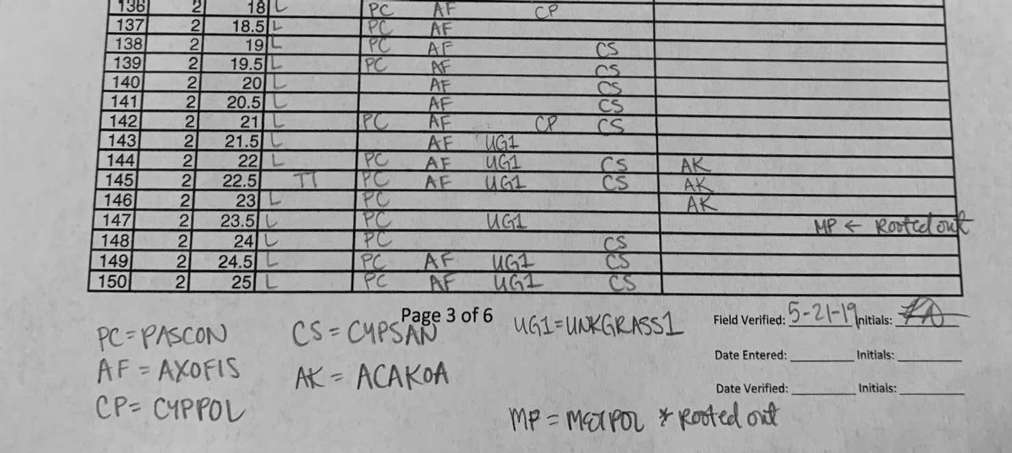

**Figure SOP 10.8.** Sample of wet forest understory cover where the recorder utilized two letter species codes and column format.

Conducting Woody Vegetation and Tree Fern Density Counts (Forms 5, 6, 7, 9, 11, 12, 15)

Density counts are conducted for all live, or standing-dead, woody plants and tree fern species at least 0.5 m in length. Woody species are recorded differently based on the species’ lifeform and the size of the individual. Lifeform is pre-determined and permanent for each species. A list of each species detected during FTPC monitoring along with their designated lifeform can be printed from the FTPC database using the query “qs_x032_Species_lists_detections_per_park”. Lifeform, as designated in the FTPC database, dictates how a species is recorded in the monitoring plot, it does not change, and may not necessarily match occurrence of that species. Therefore, crewmembers should reference the species list query whenever the lifeform of a species is not known. The main area this can cause confusion is in the distinction between shrub and tree lifeforms. In general, if a woody plant has a main stem with a measurable DBH, and that DBH correlates to the plant’s growth, then it is recognized as a “Tree” lifeform in this protocol. If a species exhibits both shrub-like and tree-like growth, then the lifeform for that species should be listed as “Tree” in the “Lifeform” column of the species list query (the largest lifeform possible for that species). That species will always be recorded according to the size-class rules of trees. If a species grows both like a shrub and an herb, then the lifeform for that species should be “Shrub” in the species list (again the largest life-form possible for that species), and the species is recorded according to the size-class rules of shrubs. Trees and tree ferns are recorded differently based on the diameter of the individual being recorded. Conversely, diameter is not considered for shrubs and vines (Table SOP 10.7).

Trees are divided among size classes (Figure SOP 10.9) based on diameter at breast height (DBH) measured at 1.4 m above the root crown of the tree (Figure SOP 10.10, A). When trees are on a slope or uneven ground, DBH is measured from the upper side (Figure SOP 10.10, B and C). When trees are leaning, the DBH is determined by the length of the tree versus the vertical height (Figure SOP 10.10, D); leaning trees should be measured on the lower (underneath) side. A good rule of thumb, if breast height changes due to where you are standing, choose the location that facilitates measuring higher up the tree. Large trees have a DBH greater than or equal to 10 cm. Small trees have a DBH of at least 1 cm and less than 10 cm.  Tree seedlings are defined as individuals with a DBH less than 1 cm, or no measurable DBH (<1.4 m tall or long) and a length of at least 0.5 m; tree seedlings below this length are not counted. **To be included in a plot or subplot, woody species must have more than 50% of their rooting base within the boundary.**

**Table SOP 10.7** Woody vegetation lifeforms, size-classes, and datasheet forms.

| Lifeform | Size-class | Size-class description | Wet Forest | Subalpine | Coastal |
| --- | --- | --- | --- | --- | --- |
| Tree | Large | ≥10 cm DBH | Form 9 | Form 11 | Form 9 |
| Tree | Small | 1 cm DBH – 9.9 cm DBH | Form 6 | Form 11 | Form 15 |
| Tree | Seedling | <1 cm DBH (or no DBH) and longer than 0.5 m | Form 5 | Form 12 | Form 15 |
| Tree Fern | Large | ≥10 cm diameter | Form 7 | Form 7 | - |
| Tree Fern | Small | <10 cm DBH  and longer than 0.5 m | Form 5 | Form 12 | - |
| Shrub | - | longer than 0.5 m | Form 5 | Form 12 | Form 15 |
| Vine | - | longer than 0.5 m | Form 5 | Form 12 | Form 15 |

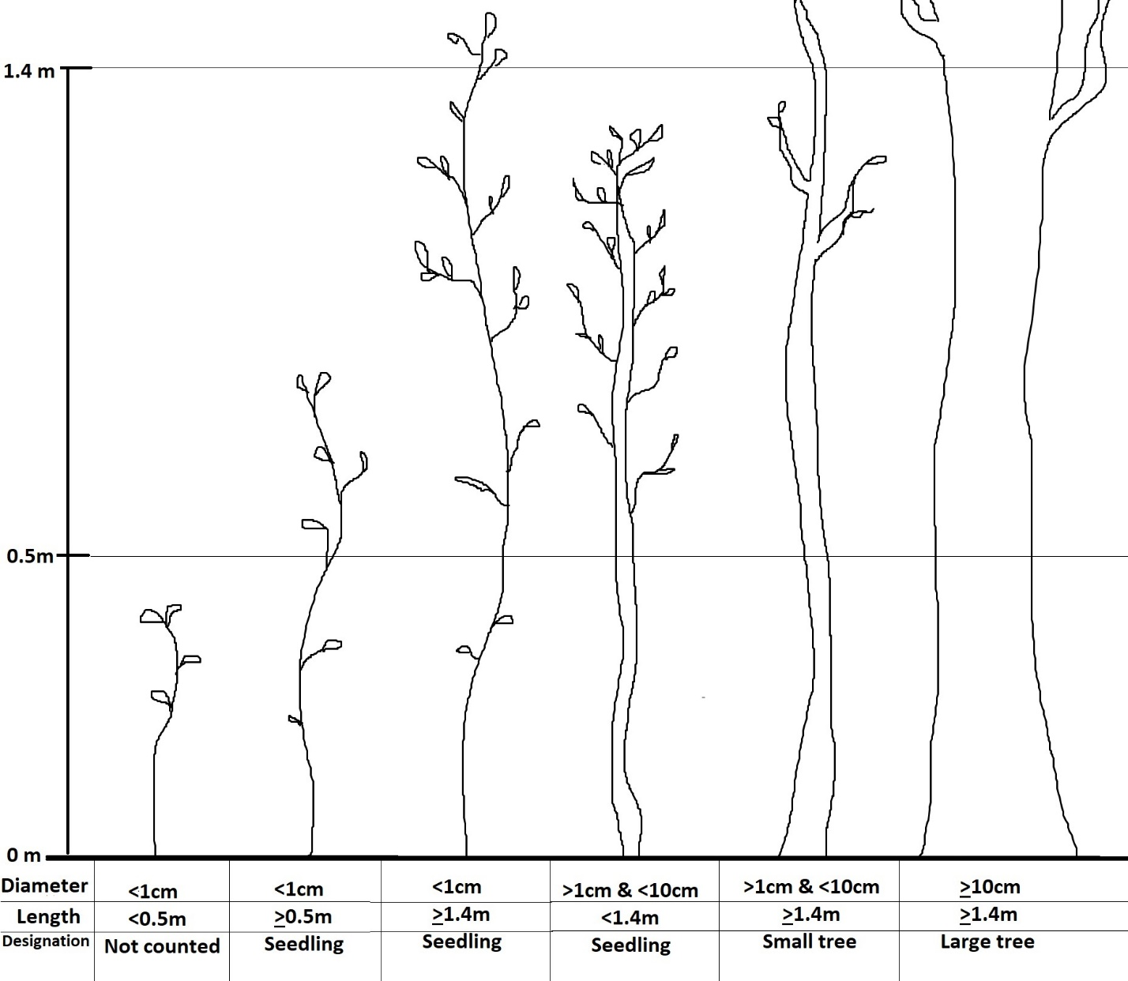

**Figure SOP 10.9.** Tree size classes based on diameter at breast height (DBH). Tree seedlings may have no measurable DBH but must be at least 0.5 m in length.

Large tree ferns have a caudex (trunk-like rhizome) diameter greater than or equal to 10 cm. The diameter is measured approximately 0.1-0.2 m below previous years frond growth, or wherever is most representative of the caudex diameter.  In areas like the Kahuku Wet Forest in HAVO, Large tree fern fronds grow at ground level, with no visible caudex. For these Large tree ferns, diameter is measured at the base of the fiddlehead/frond cluster and caudex length is recorded as 0.01 m. Small tree ferns have a caudex diameter less than 10 cm and a total length (caudex length + frond length when stretched) of at least 0.5 m; tree ferns below this length are not counted. Because Small tree ferns are counted if total length with frond outstretched is at least 0.5 m, there will be instances that a small tree fern is tallied but has a caudex length of <0.5 m; the length class of L0 (<0.5 m) is used in this instance and is only used for small tree ferns, not for shrubs, seedlings, or vines. **To be included in a plot or subplot, tree ferns must have more than 50% of their terminal end (i.e., where the fiddleheads originate) within the boundary** (see specific sections on Large Tree Ferns and Small Tree Ferns for more information). 

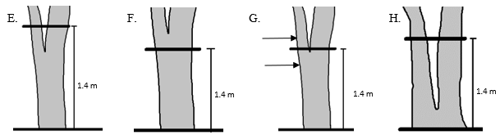

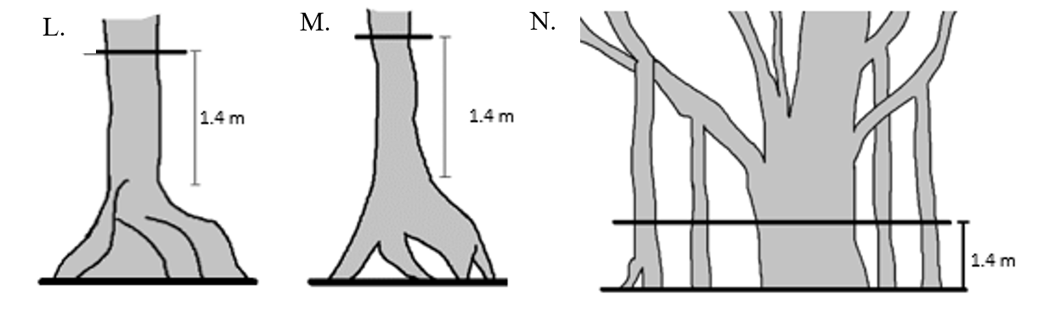

**Figure SOP 10.10.** Measuring diameter at breast height (DBH) in varying situations. A) On level ground, B) On a slope, C) Uneven ground, D) Leaning tree, E) Tree forking below DBH, F) Tree forking above DBH, G) Tree forking at DBH, measure directly above or below, H) Stilt roots/Prop roots, I) Swelling at DBH, measure directly above or below, J) Branch at DBH, measure directly above or below, K) Depressions or missing wood at DBH, measure directly above or below, L) Buttressed roots, measure DBH above root crown, M) Stilt roots/Prop roots, measure DBH above root crown, and N) *Ficus* species with pillar/prop roots should be measured using the Rooting Extent Circumference at Breast Height (RECBH).

Atypical Trees

DBH measurements are frequently used to estimate biomass. When a tree exhibits atypical form, a diameter at breast height can sometimes result in erroneous biomass estimation. Some of the most common atypical tree forms are discussed below along with established approaches for measuring them.

*Forked trees / Multiple boles* – For those individuals that are **visibly forked below** 1.4 m (Figure SOP 10.10, F and H) each individual bole is measured at 1.4 m. If the fork occurs at 1.4, **Large**: If one bole measures 10 cm or more, the tree is recorded as a large tree and any additional boles >10 cm, or at least one-third the size of the largest bole, will be measured and recorded as boles from the same individual. **Small**: If the largest bole is less than 10 cm, but more than 1 cm, it will fall into small trees size class and no matter how many bole/stems are attached to the same individual, it will be tallied only once. **Seedling**: Similarly, if DBH is <1 cm it will tally as one seedling. For those individuals **forked above 1.4 m** (Figure SOP 10.10, E), DBH will be measured normally at DBH.

*Irregularities* - If irregularities (e.g., swellings, bulging [Figure SOP 10.10, I], branches [Figure SOP 10.10, J], depressions [Figure SOP 10.10, K]) occur at 1.4 m, the diameter immediately above (first option) or below (second option) the irregularity where it does not affect normal stem form should be measured. If a tree is missing wood or bark, DBH should not be reconstructed; instead, DBH will be measured as is unless the missing bark or wood is a localized anomaly, in which case DBH should be measured immediately above or below as previously described (Figure SOP 10.10, K).

*Buttressed roots* - If buttressed roots are present, the diameter should be measured 1.4 m above the root crown along the stem (Figure SOP 10.10, M).

*Stilt roots* – If stilt roots are present, the diameter should be measured 1.4 m above the root crown along the stem (Figure SOP 10.10, N). *See epiphytes and Pandanus tectorius below.*

*Fallen Trees* (alive) – It should be recorded as "fallen tree” in the comments. Fallen trees are still measured normally regardless of how it has fallen (i.e., whether it is in the duff layer or more than 0.5 m off the ground) and whether it is still rooted or uprooted. After a hurricane/typhoon, field crews are likely to encounter many fallen trees. **For fallen trees that do not exhibit phototropism or gravitropism** (Figure SOP 10.11, A), the diameter of fallen tree will be measured 1.4 m from the root crown along the length of the stem (if safe to do so). **For fallen trees that do exhibit phototropism or gravitropism** (Figure SOP 10.11, B), branches of fallen tree show phototropism/gravitropism and look like individual trees, not tree branches. Measure each bole as an individual tree but group them together by filling in the TC # column with a number to signify tree complex. Also measure length and diameter of “old main stem.”



**Figure SOP 10.11.** A fallen tree that does not exhibit phototropism/gravitropism. B) Branches of fallen tree show phototropism/gravitropism and look like individual trees. C) An example of a tree complex.

*Tree Complex* - A “tree complex” can be used in several situations. 1) There is a tight cluster of trees, and it is unclear which ones are connected and which ones are distinct individuals. 2) The tree is one individual, but it needs to be recorded as separate individuals to accurately monitor it. For example, a fallen tree displaying phototropism/gravitropism cannot be accurately monitored as one individual. 3) Other situations where it is helpful to measure each bole as an individual tree.

1. **One individual or multiple individuals?** When two or more trees are butting up against one another, it can be difficult to discern whether it is one individual or multiple individuals, especially if other plants are growing on and around the trees. If there are two or more tree trunks that seem to be connected but the connection between the trunks is not seen, the crew member should record each tree as a separate individual and then write “Tree Complex 1” in the comments for all individuals that may be connected (if “Tree Complex 1” has already been used, then use “Tree Complex 2, etc.). All tree complexes should be documented using a “Field Maps” point and photographs.
2. **Fallen Tree with phototropism/gravitropism.** If a fallen tree continues to grow for many years, its branches will begin to grow vertically due to phototropism and gravitropism. The tree branches may appear like individual trees all connected to the old, fallen individual (Figure SOP 10.11, B). If this is encountered, a “tree complex” can be used on the datasheet to measure each tree branch as an individual tree while still recognizing that each tree is part of the same complex. In the old fallen tree example, the top of the old main stem of the fallen tree is now considered the root crown for each tree in the complex. This new root crown is used to determine where the diameter measurement is taken (1.4 from root crown) along each tree. Measure each bole as a separate individual. Each bole's rooting height will be R1 (not epiphytic). Be sure to take pictures of a tree complex. **Small and large trees are recorded if part of the tree complex; however, seedling sized trees are not recorded.** Trees that are part of a “tree complex” are considered in or out of the plot based on the root crown location of each bole (not the roots of the old fallen tree). For example, a fallen tree complex may have some boles in quad 1, quad 2, and some boles outside the plot that are not counted (even though the boles are all part of the same individual). Each bole that is part of the complex is recorded as a separate individual on the datasheet with “Tree Complex 1” written in the comments line (if “Tree Complex 1” has already been used, then use “Tree Complex 2, etc.). If the same fallen tree has both large trees and small trees, record as usual on small trees data form, and make notes in the margins to state how many small trees in each size class are part of the tree complex (i.e., 5 1-5 METPOL are from TC-1). If the tree complex has only small trees, record as mentioned above with the additional notes of length/diameter of the fallen main stem; remember, because you are assigning it a Tree Complex # Field Maps photo and point should be taken. All tree complexes should be documented using a “Field Maps” point and photographs. Whenever possible, a tree complex should include a measurement (diameter and length) of the main stem of the old fallen tree to estimate volume and compare with tree measurements from prior sample cycles, if necessary.
3. **Other.** Sometimes an individual tree that started growing as an epiphyte can result in weird connections between boles making it difficult to determine root crown location, rooting height, and/or DBH measurement locations (Figure SOP 10.11, C). Any tree, or cluster of connected trees, that causes confusion may be assigned a tree complex number to measure each bole as an individual to provide extra information for future repeatability. For example, it may be helpful to determine the rooting height separately for each bole.

*Diameter tape is blocked (cannot wrap around tree)* - Diameter is primarily measured with diameter tape wrapped around the bole. There may be instances when the primary method of measuring diameter is not feasible (e.g., trees with intertwined trunks or crew member(s) cannot safely reach around tree). A linear estimate can be used as an alternative method to attain DBH. If a linear estimate is taken, it should be recorded and noted in the comments section (noted as LE). To take a linear estimate, hold the diameter tape and line up the 0 marker to the left edge of the bole, the linear estimate will be the measurement on the right edge of bole. The diameter tape is two-sided, one side is marked to calculate diameter when wrapped around something (i.e., a tree’s circumference) and one side is marked to measure linearly. Diameter tape should be held taut and once lined up with the 0 marker, the tape should not move. Calipers are another alternative method to attain DBH, this should be noted in comments section (noted as C). Calipers work best when a bole is uniform in circumference. When diameter is not measurable (e.g., it is unsafe to access tree or the tree is a high rooted epiphytic tree), then an ocular estimate should be recorded and noted in the comments section (noted as OE), and a picture taken to help document. To take an ocular estimate it is best to compare the bole to a nearby measurable bole.

*None of the above* - If an atypical tree is encountered that does not fit any of the examples provided, simply estimate a DBH that is proportional to its biomass (use other typical form trees of the same species as reference), provide additional measurements and/or notes in the comment section, and take reference photos!

Wet Forest, Limestone Forest, and Mangrove Forest Communities

Density count data collected in each forest community differ among plant life form and size class (Table SOP 10.8). Detailed descriptions for each plant life form size class are provided below.

**Table SOP 10.8.** Data collected in wet forest, limestone forest, and mangrove forest according to vegetation sample group.

| Plot Size (m) | Sample Group | Tally Count | Living Status | Diam. | No. of Boles | Vigor Class | Fl/Fr | Rooting Height Class | Length Class | Foliar Height Class |
| --- | --- | --- | --- | --- | --- | --- | --- | --- | --- | --- |
| 20 x 50 | Large Trees (≥10 cm DBH) | X | X | X | X | X | X | X | X1 |  |
| 20 x 502 | Large Tree Ferns (≥10 cm Diam.) | X | X | X |  |  |  | X | X3 | X |
| 10 x 25 | Small Trees (1<10 cm DBH) | X | X | X4 |  |  |  | X |  |  |
| 2 x 50 | Small Tree Ferns (≥0.5 m length & <10 cm Diam.) | X | X |  |  |  |  | X | X |  |
| 2 x 50 | Tree Seedlings (<1 cm DBH, ≥0.5 m length) | X | X |  |  |  |  | X | X |  |
| 2 x 50 | Shrubs (≥0.5 m length) | X | X |  |  |  |  | X | X |  |

1 Classes not used, length is estimated for large dead trees (must not be leaning at angle of 45 or less to ground).

2 Large Tree Ferns are recorded throughout entire 20 x 50 m plot, *except in HAVO and KALA Wet Forest* where they are only measured in Quad 4 (10 x 25 m).

3 Classes not used; length of caudex is measured to nearest tenth of a meter for large tree ferns.

4 Two diameter classes used for small trees (1<5 cm; 5<10 cm).

Large Trees (Form 9)

Large live trees and standing dead trees (DBH ≥10 cm) are counted within the entire 20 x 50 m plot and recorded by quadrant number. Quantitative measures and notes recorded for each individual include: species, quadrant number, living status (live or dead), DBH, number of boles, vigor class (Table SOP 10.9), reproductive status, rooting height class (Table SOP 10.10), dead tree height (if applicable), tree complex number (if applicable), and any additional notes and comments. The species should be recorded for every large tree within the plot. The use of a two-letter code as opposed to the six-letter code is permitted, though discouraged as a recording habit otherwise. If two letter codes are used, the recorder must ensure that a key to the code(s) used is written on every data form that the code is used and that the code is recorded correctly. By default, a large tree is assumed to be living. If the tree is dead, then it should be indicated on the datasheet. The number of boles corresponds to how many stems have recorded DBHs for an individual tree. All boles that are at least 10 cm or at least one third the size of the largest (>10cm) bole will be measured and recorded as boles from the same individual. If unsure if a bole meets the 1/3 size requirement, record boles and upon data entry the database will reject any boles that are too small. Shrubs are tallied by foliar and rooting height classes, as well as by living status. Vigor is recorded as one of five classes ranging from healthy live to old dead based on criteria defined in Table SOP 10.9. Most trees of average health will be vigor class V2 (10-50% of branches are dead or without leaves). Reproductive status is checked for all live individuals with any evidence of flowering or fruiting.

If a tree is alive and has fallen over, it is still measured as a live tree (see “atypical trees” section for more details). Reference photos should be taken for any unusual, atypical trees along with any other additional comments. Once a tree is recorded it should be marked with chalk to avoid repeat measurements and/or missed trees.

For fixed plots in forests communities (wet forest, limestone forest, and mangrove forest), all large trees should be flagged with lime/green flagging and labeled to identify the Quadrant and Tree number (e.g., Q1 - #1, Q1 - #2, etc.). For a tree complex within a fixed plot in forest communities, the tree complex should be flagged with lime/green flagging and labeled to identify the Tree complex number (e.g., TC #1, TC # 2, etc.).

Rooting Height

Is the individual an epiphyte or does it show signs of past epiphytic establishment?

1. Yes: measure from ground to rooting crown and select corresponding rooting class.
2. No: rooting height = R1

Rooting height indicates if an individual is/was epiphytic and is recorded as the measured distance class between the root crown and the ground (Table SOP 10.10). Any individual currently growing on another plant (alive or dead) or showing past signs of epiphytic establishment, is considered an epiphyte and will receive a rooting height class of R2 or greater. A tree showing past signs of epiphytic establishment (hemi-epiphyte) may have a large gap or space underneath the root crown extending from the bottom of the root crown to the ground (Figure SOP 10.10, H). This space under the root crown results after the epiphytic roots have reached the ground and the object the epiphyte established on has decomposed. Note that as with current epiphytes, past signs of epiphytic growth always receive a rooting height class of R2 or greater (however “R4 rooted on live” would never be used in past epiphytic cases). Documenting current and past epiphytes helps to quantify epiphytic prominence in the wet forest and the importance of nurse logs for seedling establishment in some species.

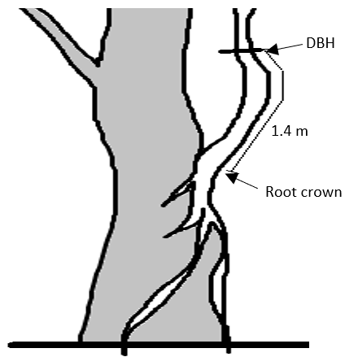

**Figure SOP 10.12.** Epiphytes are distinguished by the height of their root crown. This includes if they were epiphytic and now exhibit stilt/prop roots. Species that naturally exhibit stilt/prop roots are recorded as not epiphytic.

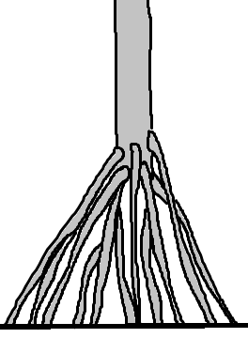

**Figure SOP 10.13.** *Pandanus tectorius* is a non-epiphytic species that naturally exhibits stilt/prop roots. Crews should record species like this as R1, rooted in the ground, not epiphytic.

Some species (e.g., *Pandanus tectorius*), commonly have prop roots creating empty space between the root crown and ground (Figure SOP 10.13). However, these types of prop roots are not created by epiphytic growth, so rooting height class is generally R1 for *P. tectorius* and species with similar growth habits. Species with a pronounced root crown that has no air space between its roots and the ground (e.g., trees with buttressed roots [Figure SOP 10.10, M], trees growing on a steep slope [Figure SOP 10.10, B and C], etc.) will be recorded as rooted “in the ground”, even though the root crown may be some distance above the ground. The important distinction when measuring rooting height is to first determine whether the individual is/was an epiphyte. If the individual is/was an epiphyte, then measure the distance from the ground to the root crown and choose the appropriate class (R2 or greater). If the individual does not show any epiphytic signs, then it receives a rooting class of R1.

Standing Dead Trees

For all large standing dead trees, height is also recorded to enable biomass calculations. Dead trees and stumps are recorded including diameter and height if they are standing (leaning at an angle of 45 degrees or greater from the ground) and have an intact bole with a measurable DBH (must be at least 1.4 m tall) of 10 cm or more. If a dead tree is leaning at less than 45 degrees from the ground, this individual would be counted as coarse woody debris (form 10 below).

If there is a dead standing tree that is epiphytic and rooted R5, the dead height given should be the estimated height of the dead tree in question. For example, a dead standing tree that is 5 m tall and rooted at 3 m high, should have the dead height of 5 m, not 8 m.

If a dead tree is missing the features (leaves, bark, etc.) needed to identify the species then write “Snag” in place of the species. Alternatively, if enough features are present to determine the species, writing the species is preferred to writing Snag. Note that “Snag” is not interchangeable with “Unk_Tree1.” Unk_Tree1 implies that the record is a unique species that needs further identification, while “Snag” implies a non-descript dead tree (i.e., we do not know if it is a new, unique species or common species because it is missing leaves, bark, etc.).

**Table SOP 10.9.** Plant vigor classes and descriptions adapted from Jacobi et al. (1983).

| Vigor Class | Description |
| --- | --- |
| V1 | Healthy crown and foliage; <10% of branches dead or without leaves |
| V2 | Crown partially defoliated; 10 - 50 % of branches dead or without leaves |
| V3 | Unhealthy crown; >50% of branches dead or without live leaves |
| V4 | Plant recently dead; many fine branches remain |
| V5 | Old dead; few fine branches remain and some bark loss |

**Table SOP 10.10.** Rooting height classes and descriptions for woody species and tree ferns. Rooting height indicates if an individual is/was epiphytic and is recorded as the measured distance (height) class between the root crown and the ground. *See large trees section for specifics of addressing stilt/prop roots.

| Class | Height | Type | Description |
| --- | --- | --- | --- |
| R1 | ground | Terrestrial | Rooted in the ground |
| R2 | <0.5 m | Low Epiphytes | Rooted on a low log or tree |
| R3 | 0.5<2 m | Medium Epiphytes (dead) | Rooted on dead wood or tree ferns |
| R4 | 0.5<2 m | Medium Epiphytes (live) | Rooted on live wood or tree ferns |
| R5 | ≥2 m | High Epiphytes | Rooted greater than 2 m above the surface |

Root, Basal, and Epicormic Sprouts

In areas that have burned (e.g., East Rift of HAVO), additional measurements are taken on large trees. Sprouting at the base (basal sprouts), along the trunk (epicormic sprouts), or from the roots (root sprouts) of a snag indicates that the large standing dead tree is still alive and these root, basal, and/or epicormic sprouts should be considered when assigning vigor class. Basal and root sprouts tend to cluster at the base of the snag creating a shrub-like clump consisting of many stems. When basal sprouts and/or root are present, record 1) height of the tallest sprout, 2) width of the entire sprout complex at the broadest point, and 3) width perpendicular to the axis of the broadest point. These three measurements allow volume to be calculated for the basal sprouts. If the snag where sprouts originated has fallen or the existing stump does not have a DBH of >10cm, this volume measurement is not necessary. Instead, the sprouts will fall into its appropriate seedling or small tree size class and tallied. If unsure of how to measure, follow all above guidance and take photos to document.

Ficus

*Ficus* species are characterized by their spreading crowns with extending branches and numerous aerial roots hanging from their trunk and branches. Over time these aerial roots reach the soil and become pillar/prop roots. These pillar/prop roots resemble boles and at times it may be hard to distinguish boles from roots. *Ficus* species often start as an epiphyte, overtime its pillar/prop roots gradually encircle and kill its host tree. If *Ficus* pillar/prop roots are not present on an individual, measure normally according to previously stated guidance. However, if pillar/prop roots are present (Figure SOP 10.10, O) the crew does not need to measure each pillar/prop root. Instead, the crew should measure the “rooting extent circumference at breast height” (RECBH), which refers to the circumference (in centimeters) encircling all the pillar/prop roots. Crews should also record a tree height estimate and the area of the *Ficus* that exists within the plot. This should be drawn on the Plot Location (Form 1) map, along with the location where the *Ficus* circumference crosses transect lines.

*Pandanus dubius* (encountered at WAPA)

*Pandanus dubius* are characterized by their erect trunk supported by numerous prickly prop roots. Their broad leaves, which are up to 20 cm wide and over a meter in length, have spines on both margins and midrib. These leaves are spirally arranged towards the ends of the branches in a rosette. *P. dubius* rosettes grew in compact clusters making it hazardous and difficult to reach the trunk. Instead of measuring each individual *P. dubius,* crews should record a tally of rosettes in each quadrant. The tally is based on the location of the rosette in the quadrant (>50% in quadrant), not where it is rooted. Total tally includes all four quadrants. Tally of *P. dubius* will be recorded on the small tree datasheet. When entering in the database, select the “Small Woody Species” tab, enter “PANDUB” for species then select “Plot” in the drop-down for Sample Unit (currently called “Transect” but this will be updated), then enter the total count of PANDUB rosettes within the entire plot. In the Comments section, enter the count of rosettes for each quad.

*Pandanus tectorius* (diameter at root crown DRC)

DBH is measured at 1.4 m above the root crown along the stem. This measurement can be problematic for *Pandanus tectorius*, as the root crown of the stilt/prop roots can be 1-2 m tall and climbing a *P. tectorius* tree to reach 1.4 above the root crown is not recommended. Instead, the crewmember can measure the “diameter at root crown”. This measurement is abbreviated as DRC (diameter at root crown) and should not be confused with DBH. When recording a DRC, put the measurement in the “Comments” column of the datasheet (not the DBH column). When entering in the database, select “DRC” from the dropdown menu in “Large Woody Species” Tab under the column “Measurement Type” and enter the DRC measurement in the “Other Measurement” (cm) column.

Canopy Height (Form 8)

Canopy height is the height of a subset of trees within the plot, or in proximity, the plot. Height is measured to the nearest tenth of a meter from the ground or a measured distance up the tree that is visible to the top of the tree using a clinometer and meter tapes (refer to SOP #11 Using a Clinometer to Measure Height and Slope). For each tree, species, living status, DBH, canopy layer, and quadrant number are also recorded. Canopy layers include “Emergent”, “Main Canopy”, and “Sub Canopy” (Figure SOP 10.14). Note presence/absence of each canopy layer, canopy layer cover class, and dominant species present in each canopy layer, if present. If there are more than one species of note in a canopy layer, record up to 3 species and circle the most dominant species on the datasheet. If all canopy layers are present, 1 emergent tree, 3 main canopy trees, and 1 subcanopy tree should be recorded. In areas with numerous large standing dead trees, a standing dead tree should be measured for canopy height as one of the main canopy trees. If canopy height varies throughout plot, more heights may be recorded to offer a more accurate range. Trees that are rooted outside of the plot may be measured if it helps illustrate the variation in the canopy (e.g., there are <4 trees in the plot, no emergent trees within the plot, etc.). If a tree is rooted out of the plot, note “out” for the quadrant number. Tree ferns may be the dominant species in the main canopy or subcanopy. When this occurs, the tree fern species should be recorded in its canopy layer; however, tree fern height measurements are not necessary as foliar height will be recorded on the large tree fern data form (Form 7).

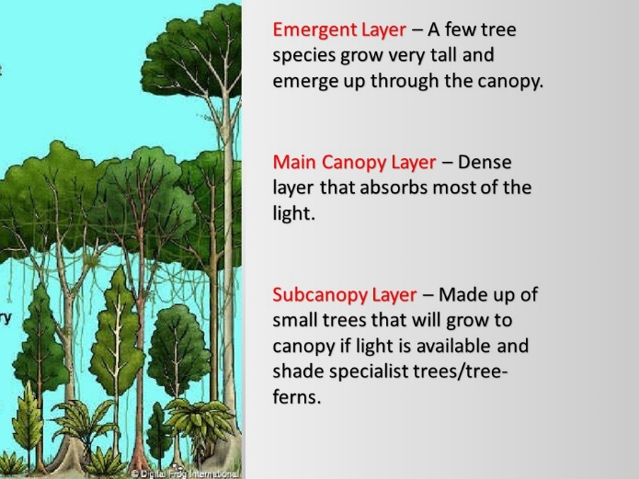

**Figure SOP 10.14.** Canopy divided into three layers: Subcanopy, Main Canopy, and Emergent Layer.

Large Tree Ferns (Form 7)

A tree fern grows with thick, often erect, trunk-like rhizome called a caudex (plural caudices) that elevates the fronds above ground level. Species in the following genera are recorded as tree ferns: *Cibotium*, *Sadleria*, and *Sphaeropteris*. Live and dead large tree ferns (caudex diameter ≥10 cm) are counted throughout the 20 x 50 m plot, except at HAVO & KALA Wet Forest Communities where they are only measured in quadrant 4 (Q4) due to high densities. Quantitative measures recorded for each individual include: species, quadrant number, caudex diameter, rooting height (Table SOP 10.10), frond foliar height class (Table SOP 10.11), caudex length, and living status (assumed alive unless noted dead in comments). Tree ferns are recorded as live if any portion of the individual is alive including fiddleheads. To be counted as dead, the tree fern should be obviously dead (all fronds dead and/or no fronds arising anywhere from the caudex). Rooting location is not used to determine occurrence in the plot because it is often difficult to pinpoint where a tree fern begins, instead, the terminal end of the caudex (where fronds normally arise) must be inside the plot (50% or more), this applies to both live and dead tree ferns. The measurement for **caudex diameter** is taken approximately 0.1-0.2 m below the terminal end or the location that is most representative of the caudex diameter and is measured to the nearest tenth of a centimeter (e.g., 10.3, 18.2 cm). Because tree ferns are uniform in circumference, tree calipers may be used to measure tree ferns. If the tree fern is tall and the terminal end is too high, it is advised to take a measurement anywhere along the caudex that is best representative of the caudex diameter. Note that sometimes caudex diameter is used interchangeable with “DBH” even though it is not recorded at breast height. **Rooting height** is recorded as the measured distance class between the base of the individual and the ground (Table SOP 10.10). To characterize the role of tree ferns within the community profile, frond foliar height class and caudex length are also recorded. Frond **foliar height** class (Table SOP 10.11) indicates where the highest frond of a live individual, or terminal end of the dead individual, is within the forest vertical profile, regardless of its caudex length or rooting height. Frond foliar height is the vertical distance between the ground and the highest live frond (or dead terminal end).  **Caudex length** provides an estimate of tree fern age and biomass and is measured from where the caudex emerges from the ground to the terminal end of the caudex. The caudex length measurement should contour the shape of the caudex and round to the nearest tenth of a meter.

In the wet forest plant communities tree fern density may be very high, it is recommended that once a tree fern is recorded it should be marked with **chalk** to avoid repeat measurements and/or missed tree ferns.

If a dead tree fern is missing the features needed to identify the species, then write “**Snag**” in place of the species. Alternatively, if enough features are present to determine the species, writing the species is preferred to writing Snag. Note that “Snag” is not interchangeable with “Unk_Fern1”. Unk_Fern1 implies that the record is a unique species that needs further identification, while “Snag” implies a non-descript dead tree fern.

**Table SOP 10.11.** Foliar height classes for large tree ferns. Foliar height is an indication of where the individual is within the forest vertical profile and is measured as the vertical distance from the ground to the individual’s canopy or the tallest live piece (not necessarily following the caudex). Alternatively, caudex length does follow the stem and is an indication of the individual’s age.

| Class | Foliar (frond) Height |
| --- | --- |
| F0 | <0.5 |
| F1 | 0.5<1 m |
| F2 | 1<2 m |
| F3 | 2<5 m |
| F4 | ≥5 m |

Small Trees (Form 6)

Live and standing dead small trees (1 < DBH < 10 cm) are counted within the 10 x 25 m nested subplot (Q4). Individuals are tallied in two diameter groups (1 < DBH < 5 cm and 5 ≤ DBH < 10 cm) by species, living status, and rooting height class (Table SOP 10.10). Recorded trees should be marked with chalk to avoid repeat measurements and/or missed trees.

Forked small trees are tallied (Figure SOP 10.15) based on the diameter of the largest live stem. If there is a dead stem ≥10 cm, then the individual would be counted as a large tree. If many stems are sprouting from a single dead main bole that is <10 cm, then those stems are part of one individual and tallied as one point based on largest live stem.

Dead small trees and stumps are recorded if they are standing (or leaning at an angle of 45 degrees or greater from the ground) and have a bole with a measurable DBH (must be at least 1.4 m long). If leaning at less than 45 degrees from the ground, this individual would be counted as coarse woody debris.

If a tree is part of a tree complex, the tree’s vertical branches are recorded as separate individual trees, these trees should be tallied as usual but have a note in the margins to state how many small trees in each size class are part of the tree complex (i.e., 5 1-5 METPOL are from TC-1). If there is a tree complex that has only small trees, record as mentioned above with the additional notes of length/diameter of the fallen main stem; remember, because you are assigning it a Tree Complex # Field Maps photo and point should be taken. Only count these trees if the rooting crown is within Q4 (see Atypical Trees section for additional information). Reference photos should be taken for any atypical trees and tree complexes with the time the photograph was taken recorded on the datasheet along with any additional comments.

Small Tree Ferns (Form 5)

Live and dead small tree ferns with an entire length (stretched out frond + caudex) ≥ 0.5 m and caudex diameter < 10 cm are counted within the 2 x 50 m nested subplot (along TR 3). Individuals are tallied (Figure SOP 10.15) by species, living status, rooting height class (Table SOP 10.10), and length class of the caudex (Table SOP 10.12). Note that caudex length may be < 0.5 m and counted as long as the entire plant with its stretched out frond + caudex exceeds 0.5 m, the stretched out frond is only used to determine if the individual will be recorded or not, frond length is not included when estimating length class.

Is the individual 0.5 m or longer from rooting base to tip of stretched frond?

1. No, do not record.
2. Yes, Is the diameter of caudex less than 10 cm?
   1. No, record separately as Large Tree Fern (Form 7)
   2. Yes, record as small tree fern
      1. Record all measurements including caudex length which can be less than 0.5 meters (L0).

Tree Seedlings (Form 5)

Live and dead standing tree seedlings that have a DBH < 1 cm are counted within the 2 x 50 m nested subplot (along TR 3). Individuals that have no measurable DBH (its length is less than 1.4 m), may have a diameter larger than 1 cm, but must be at least 0.5 m in length to be counted as a seedling (Figure SOP 10.9). Individuals are tallied (Figure SOP 10.15) by species, living status, rooting height class (Table SOP 10.10), and length class (Table SOP 10.12). Length class for woody species is measured from the base of the stem to the growing tip and provides data on size and/or age structure for small woody individuals.  Note that if a clump of stems are attached to the same individual, the largest stem should be measured to determine the size class of the individual. Once the representative size class for the clump is determined, none of the individuals of that clump are tallied for any other class or more than once as a seedling.

Shrubs (Form 5)

Live and dead shrubs are counted within the 2 x 50 m subplot (along TR 3) and do not have a diameter requirement to be counted but must be at least 0.5 m in length. Individuals are tallied (Figure SOP 10.15) by species, living status, rooting height class (Table SOP 10.10), and length class (Table SOP 10.12). When shrubs are sprawling or possess multiple stems, the length of the longest stem is used to determine the appropriate length class. Use lifeform designation on species list to determine if species should be recorded as a small tree or a shrub. If a species is described in the literature (e.g., Manual of Flowering Plants) as a shrub and small tree, it should be recorded as a small tree (larger lifeform). If a species is described in the literature as an herb or sub-shrub/shrub, record as a shrub (larger lifeform).

Vines (Form 5)

Live and dead vines are included within the 2 x 50 m subplot (along TR 3) and do not have a diameter requirement to be counted but must be at least 0.5 m in length and rooted in the subplot as they are not captured well by any other measurement. Individuals are tallied (Figure SOP 10.15) by species, living status, rooting height class (Table SOP 10.10), and length class (Table SOP 10.12). Vines are often epiphytic, so be sure to look up to scan the canopy for presence of vines. It may be hard to determine at times if a vine is rooted within the subplot, use your best judgement to make this decision.

**Table SOP 10.12.** Length classes for small tree ferns, shrubs, seedlings, and vines.

| Length Class | Length (m) |
| --- | --- |
| L0 | <0.5* |
| L1 | 0.5<1 |
| L2 | 1<2 |
| L3 | 2+ |

*only for small tree ferns



**Figure SOP 10.15.** How to tally on datasheets. A) Each dot/line represents one individual. The dots should be marked first and then lines follow to connect the dots. The order or placement of the lines are not important (e.g., if there are 4 dots and 2 lines, no matter where the lines are it will be universally read as 6). B) Example of different numbers.

Subalpine Shrubland Community

Like the forest communities, vegetation is measured within a 20 x 50 m plot in the subalpine shrubland community. However, subplot sizes vary to account for differences in community structure (i.e., fewer trees). Details on each sampled parameter by plant life form and size class are provided below (Table SOP 10.13). Specifics on quantitative measurements are the same as forest communities unless stated below.

Small and Large Trees (Form 11)

All live and standing dead large trees (DBH ≥1 cm) are counted within the entire 20 x 50 m plot and recorded by quadrant number. Quantitative measures and notes recorded for each individual include species, quadrant number, living status (live or dead), DBH (must have DBH >1 cm), number of boles (if numerous, see large tree rules; if largest bole is <10 cm then measure only the largest bole), vigor class (Table SOP 10.8), reproductive status, live height estimate, tree complex number (if applicable), and any additional notes and comments. Guidance for tree measurement and recording is the same as stated for the forest communities with the following differences. Because live height is recorded for all trees, canopy height estimates are not necessary in this community. Rooting height class is not recorded for this community because epiphytic growth is very rare in these drier high elevation areas.

Tree Seedlings, Shrubs, Small tree ferns, and Vines (Form 12)

Live and standing dead tree seedlings, shrubs, small tree ferns, and vines are counted within the 2 x 50 m subplot (along TR 3) and are tallied by species, living status, and length class (Table SOP 10.12). Everything is recorded as in forest communities *except that rooting height is not recorded.*

**Table SOP 10.13.** Data collected in subalpine shrubland according to vegetation sample group.

| Plot Size (m) | Sample Group | Tally Count | Living Status | Diam. | No. of Boles | Vigor Class | Fl/ Fr | Height | Length Class | Foliar Height Class |
| --- | --- | --- | --- | --- | --- | --- | --- | --- | --- | --- |
| 20 x 50 | Large Trees (≥10 cm DBH) | X | X | X | X | X | X | X1 |  |  |
| 20 x 50 | Large Tree Ferns (≥10 cm Diam.) | X | X | X |  |  |  |  | X2 | X |
| 20 x 50 | Small Trees (1<10 cm DBH) | X | X | X3 | X | X | X | X1 |  |  |
| 2 x 50 | Small Tree Ferns (≥0.5 m length & <10 cm Diam.) | X | X |  |  |  |  |  | X |  |
| 2 x 50 | Tree Seedlings (0<1 cm DBH, ≥0.5 m length) | X | X |  |  |  |  |  | X |  |
| 2 x 50 | Shrubs (≥0.5 m length) | X | X |  |  |  |  |  | X |  |

1 Live height is recorded for all individual trees.

2 Classes are not used; length of caudex is measured to nearest tenth of a meter for large tree ferns.

3 Two diameter classes used for small trees (<5 cm; 5-10 cm).

Coastal Community

Vegetation is measured within a 10 x 20 m plot in the coastal community. Plot and subplot sizes differ from the forest and shrubland communities due to the restricted linear nature of this community (Figure SOP 10.2). Details on each sampled parameter by plant life form and size class are provided below (Table SOP 10.14). Specifics on quantitative measurements are the same as forest communities unless stated below.

**Table SOP 10.14.** Data collected in coastal communities according to vegetation sample group.

| Plot Size (m) | Sample Group | Tally Count | Living Status | Diam. | No. of Boles | Vigor Class | Flr/Frt | Height Class |
| --- | --- | --- | --- | --- | --- | --- | --- | --- |
| 10 x 20 | Large Trees (≥10 cm DBH) | X | X | X | X | X | X |  |
| 2 - 2 x 20 | Small Trees (1<10 cm DBH) | X | X | X1 |  |  |  | X |
| 2 - 2 x 20 | Tree Seedlings (0<1 cm DBH, ≥0.5 m length) | X | X |  |  |  |  | X |
| 2 - 2 x 20 | Shrubs2 (≥0.5 m length) | X | X |  |  |  |  | X |

1 Two diameter classes used for small trees (<5 cm; 5-10 cm).

2 Shrubs at KALA coast are counted if length is ≥0.2 m.

Large Trees (Form 9)

Same as forest communities.

Small Trees, Tree Seedlings, Shrubs, and Vines (Form 15)

Live and standing dead small trees, tree seedlings, shrubs, and vines are counted within two 2 x 20 m subplots (along TR 1 and TR 3). Individuals are tallied by species, living status, and length class. Everything is recorded as in forest communities*. In KALA, shrubs are counted if the length is 0.2 m or more. In KALA, the shrub species Wikstroemia uva-ursi and Scaevola taccada were counted on the cover line* ***but not incorporated into the shrub count*** *as individual plants were very difficult to tease apart.*

Canopy height

In the coastal strand plant community is recorded on the Plot Location form. Assign one maximum vegetation height for the live vegetation within the plot and denote the species.

Definitions

*Basal Sprouts:* Shoots that grow from buds on the base of a tree or shrub.

*Caudex,* plural *Caudices*: a thick, trunk-like rhizome, especially of tree ferns.

*Caudex Diameter*: Provides an estimate of tree fern biomass and is measured approximately 0.2 m below the previous year’s frond shed or where representative of the caudex.

*Caudex Length*: Provides an estimate of tree fern age class and biomass and is measured from where the caudex emerges from the ground to the terminal end (base where the fiddleheads originate). The stem length measurement contours to the shape of the caudex.

*Coarse Woody Debris (CWD)*: Down dead wood consisting of fallen trees, large dead branches and large fragments of wood found on the ground or elevated off the ground (<2m) up to 45°, but no longer supported by roots. CWD does not include live material, standing dead trees (> 45°), or the part of the bole/roots below the root crown.

*Diameter at Breast Height (DBH)*: The diameter of a tree 1.4 m up the trunk from the root crown. Specific instructions regarding this subject can be found under the Conducting Woody Vegetation and Tree Fern Density Counts section of this SOP.

*Epicormic Sprouts:* It is the growth of new sprouts/shoots from epicormic buds that lie dormant beneath the bark. This is a plants response to damage or stress.

*Gravitropism:* Is the change in the direction of a plant’s growth in response to gravity.

*Phototropism:* Is the growth of an organism in response to a light stimulus. Most often observed in plants, as they grow toward the source of light.

*Root Crown:* The location where the plant’s roots begin which may or may not be where they enter the ground.

*Rooting Height*: The vertical distance between the ground and the root crown. This measurement is used to investigate epiphytic stratification.

*Root Sprout:* A living shoot which grows from the root of a plant whose above-ground portion has been wounded or stressed. Root sprouts grow from the root apical meristems of the parent tree, this occurs within the diameter of its roots at the base of the tree.

*Snag:* Used in the “Species” column for an unidentifiable (species unknown), dead standing tree. Can be a large tree or small tree. Alternatively, if the species can be determined, write in the species instead of Snag. Snag is not interchangeable with “Unk_Tree1.” Unk_Tree1 implies that the record is a unique species that needs further identification, while “Snag” implies a non-descript dead tree - we do not know if it is a new species or common species because it is missing leaves, bark, etc.

*Surface substrate:* The top layer of the substrate or the first ground layer the pole hits when sampling cover (e.g., litter as opposed to rock if leaves are overlaying rocks).

*Tree Ferns*: Ferns that grows with thick, often erect, trunk-like rhizome called a caudex (plural caudices) that elevates the fronds above ground level. Species in the following genera are recorded as tree ferns: *Cibotium*, *Sadleria*, and *Sphaeropteris*.

*Tree Fern Foliar Height*: Vertical measurement from the ground to the top of a tree fern’s canopy regardless of where it is rooted. This measurement does not include horizontal stem length because it is intended to provide information on where a tree fern stands within the forest’s vertical profile as opposed to the age class as measured by stem length.

*Vigor*: A rating of tree health. Table SOP 10.9 displays how class ratings are delineated.

*Woody Species*: All species with ligneous tissue growth on the main stem of the plant including tree and shrub species.

*Woody Stem Height*: Measurement of an individual’s stem from where it is rooted to the height or length at which the plant branches or displays caespitose growth. This measurement will apply to both standing and fallen woody species.

Literature Cited

Elzinga, C. L., D. W. Salzer, J. W. Willoughby, and J. P. Gibbs. 2001. Monitoring Plant and Animal Populations. Blackwell Science, Malden, MA.

Jacobi, J. D., G. Gerrish, and D. Mueller-Dombois. 1983. Metrosideros dieback in Hawaii: a comparison of adjacent dieback and non-dieback rain forest stands. New Zealand Journal of Ecology 6:79-97.

Mueller-Dombois, D. and H. Ellenberg. 1974. Aims and Methods of Vegetation Ecology. John Wiley & Sons, New York, NY.

USDA Forest Service. 2005. Field Instructions for the Inventory of Pacific Islands. Forest Inventory and Analysis Program, Pacific Northwest Research Station, Portland, OR.